Icp4-Task1

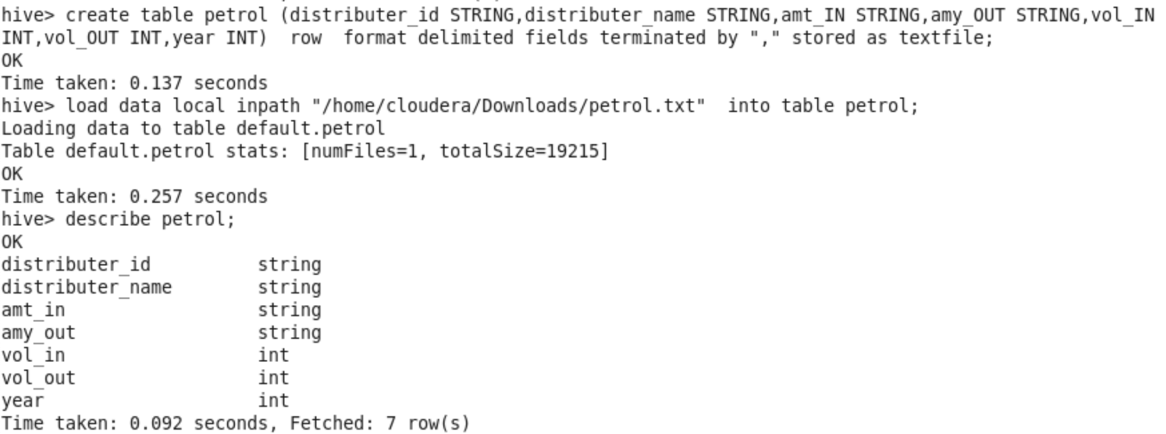

QUERY1:

In real life what is the total amount of petrol in volume sold by every

distributor?



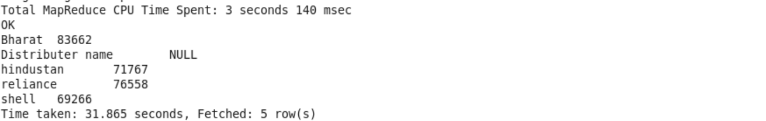

QUERY2:

Which are the top 10 distributors ID’s for selling petrol and also

display the amount of petrol sold in volume by them individually?



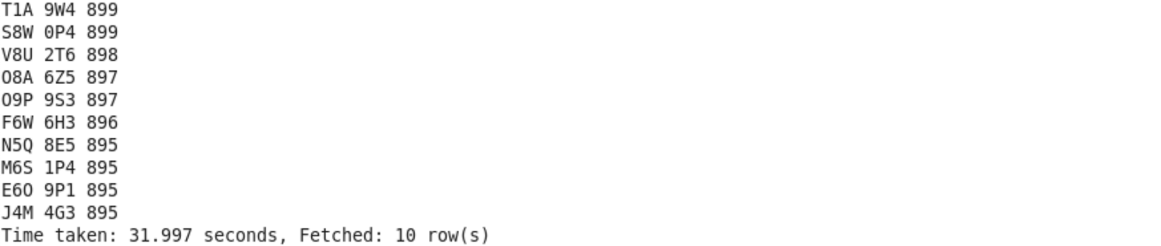

QUERY3:

Find real life 10 distributor name who sold petrol in the least

amount.



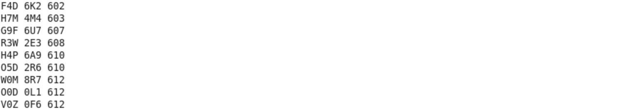

QUERY4:

List all distributors who have this difference, along with the year and

the difference which they have in that year.

